**Writer: Sandip K Luis**

**GROUP 1890**

Group 1890 was a short-lived, but highly influential collective of Indian artists formed in 1962. It was composed of twelve members – Jeram Patel as secretary, Raghav Kaneria, M. Reddeppa Naidu, Ambadas, Rajesh Mehra, Gulam Mohammed Sheikh, Himmat Shah, S. G. Nikam, Eric Hubert Bowen, Jyoti Bhatt, Balkrishna Patel and last but not the least, J. Swaminathan, the spokesperson and the ideologue of the collective. The name of the group was taken from the house-number of the residential place in which they had their first meeting. The collective had their first and last show in 1963 at New Delhi, inaugurated by then Prime Minister Jawaharlal Nehru. The catalogue essay, ‘Surrounded by Infinity’, was written by Octovio Paz, who was then Mexican ambassador to India. The aesthetic impact made by Group 1890 in their ‘primitivist’ use of materials and surfaces was soon co-opted into the indigenist art of the Madras/Cholamandal school and the so called ‘Neo-tantric’ painters. The historical significance of Group 1890 is today seen as more at the level of their ideology which paradoxically is “the deliberate absence of any ideological meaning” – in the words of Octovio Paz– than the artists’ artworks since they are hardly preserved or documented.

Certain parallels have been traced out between the aesthetic of the collective and that of European (more specifically, Spanish and Italian) artists like Antoni Tapies, Lucio Fontana and Alberto Burri. The disinclination of the collective towards the American art of 1960s in the context of cold-war politics took an explicit and critical shape in the writings of Swaminathan during Clement Greenberg’s visit to India in 1967, although the group was informally disbanded after its first exhibition since many of its members went abroad and Swaminathan and remaining artists were preoccupied with their individual pursuits.

In spite of the absence of any ideological positioning, the manifesto of Group 1890 (<http://www.theotherspaces.com/journals/001/4/1/default.aspx>) is well known for its polemic position. Published in the exhibition catalogue, it was mainly drafted by Swaminathan, as an extension of the discussion the group members had over the preceding year. The manifesto explicitly valorised the idealised and mystified subjectivity of the artist over the material manifestation of the artwork, with an aim to retrieve the alleged originality of what they called “creative act”—an untranslatable “experience in itself” of the artist-creator “bearing no relation to the work of art”. This position, perhaps, can be seen as a strategy to de-fetishise the artwork and a critique of the practices of the earlier collective, the Bombay Progressive Group, whose consciously created signature style made the painting a successful commodity.

The ideological valorisation of the artist’s subjectivity (paradoxically in the name of undoing all ideology) also made the group’s political and aesthetic agenda short-lived as well as highly alienated, as it overlooked the material and collective reality of the artwork and social practices surrounding it. However, such a high modernist negativity need not be seen as the affirmation of a monadic ego as such. Though they identified ‘creative expression as the unfolding of artist’s personality’, their notion of ‘creative process’ enjoyed an autonomous status surpassing the will and volition of the artist. Perhaps this is the feature that can be seen as the unique significance attained by the Group 1890 within and against the discursive matrix of modernism and its heroic humanism. For in their words, “Art for us is not born out of a preoccupation with the human condition. We do not sing of man, nor are we his messiahs, the function of art is not to interpret and annotate, comprehend and guide. Such attitudenising may be seen as heroic in an age where man, caught up in the mesh of his own civilisation, hungers for vindication.” Such a neutralisation of modernist heroic vanguardism (which was then monopolised in the Indian context by the American Abstract Expressionism of the 1960s) characteristically made the group an inverse image of Dadaism in terms of the nihilism shared by both. It is from this morbid reading of the present that the Group 1890 optimistically put forward a new art which would be “neither conformity to reality nor a flight from it, [but a] reality itself, a whole new world of experience, the threshold for the passage into the state of freedom.” Notwithstanding the implied puritanism of such an understanding (which necessitated the exclusion of the indigenist-Pop painter Bhupen Khakhar from the collective for his use of kitsch and pastiche), it is this concluding statement of the manifesto of Group 1890 that prompts us to consider their cynical appropriation of history and human agency productive in the last instance.

**References and Further Reading:**

Brown, R. M. (2009) *Art for a Modern India, 1947-1980,* Duke University Press.

Kapur, G. (2000) *When Was Modernism: Essays on Contemporary Cultural Practice in India,* New Delhi: Tulika.

Sheikh, G (ed.) (1997) *Contemporary Art in Baroda,* New Delhi: Tulika.

Sheikh, G. (2010) <http://www.webofstories.com/play/gulammohammed.sheikh/20>

**Illustrations:**

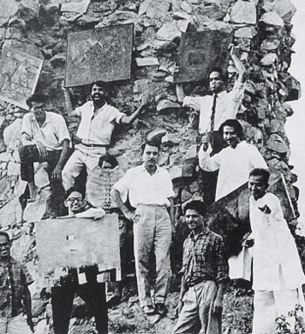  
Members of Group 1890 (top row, from left to right) **Jyoti Bhatt, Himmat Shah, Jeram Patel** (middle row, from left to right) **Raghav Kaneria** (behind a shell), **Rajesh Mehra, J. Swaminathan**, (bottom row, from left to right) **S. G. Nikam, Gulammohammed Sheikh, Ambadas, Balkrishna Patel, (Eric Bowen** and **M. Reddeppa Naidu** absent), 1963. From the catalogue of Group 1890. Photograph by **Kishor Parekh**. (Image Courtesy:Contemporary Art in Baroda, Gulammohammed Sheikh (Ed.), Tulika, New Delhi, 1997.)

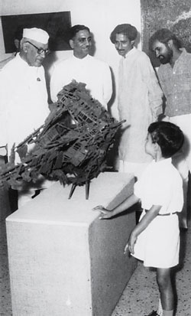  
**Jawaharlal Nehru** viewing **Raghav Kaneria**’s work with **J. Swaminathan** and **S. Harshavardhan** at the Group 1890 exhibition, Lalit Kala Akademi, October 20, 1963. (Image Courtesy: http://www.artindiamag.com/quarter03_03_12/images/profile04_03_03_12.jpg) (Accessed on 21 April, 2014)